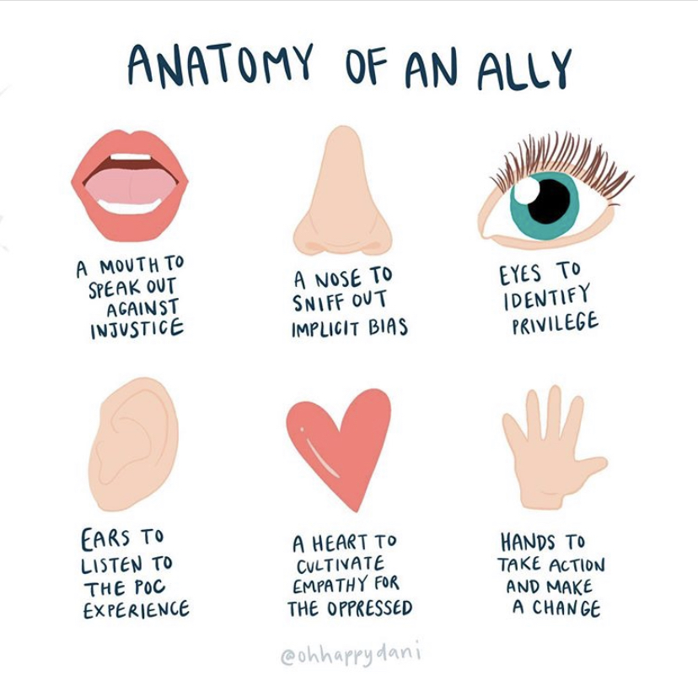
I’ll never forget the day that I stood over a cadaver for the first time. The smell of reeking formaldehyde still plagues my memory as I think about being tasked to identify every muscle, bone, and ligament in the human body. The brachial plexus still haunts me in the best way possible. As a new eager OT student, there was something about a lab coat and a summer dedicated to learning the human body that excited me. Human anatomy was the first class that I took as a graduate OT student; it was the foundation of my knowledge base as an occupational therapist.

In that class I learned about all the body parts and how they functioned. I came to understand that our body parts allow us to engage with our environment and pursue occupations that give our life meaning. In addition to this, each our our body parts have specific functions that allow us to connect with each other. Our mouth, nose, ears, eyes, and hands all play an integral role in how we connect with those around us. It is how we form bonds, relationships - it is how we ally together.

What is an ally, exactly? An ally can be defined as a person that is associated with another or others for some common cause or purpose. We can also think of an ally as a partner, a teammate… your physical therapy partner co-treating on a difficult case kind of thing. Allyship can look like Tennessee binding together for SuperBowl 1999 for the Tennessee Titans vs St. Louis Rams game (#TitanUp). But perhaps we can explore the word ‘ally’ as a verb: “to combine or unite a resource or commodity with another for mutual benefit”.

Our world has shown us that injustice and the lack of allyship has been an unfortunate part of our human experience. You may wonder what the lack of allyship looks like in our daily lives? Well…
1.The racial injustices with George Floyd or Breonna Taylor this year may serve as an recent examples.
2. Or perhaps the fact that disability rights are left unresolved within our laws.
3. Maybe it is the LGBTQIA individual who has trouble accessing OT services after a gender change surgery.
4. Or a system that prevents access to OT services for rural communities.
5. It could be the OT student who is left feeling alone as a minority in their cohort.
6. Or maybe it is the OT who silently experiences micro-aggressions as as a part of their every day experience.

These are just a few of the many examples of marginalized communities and how they experience occupational injustice in many ways, every single day. With this series, we will explore how we can change these examples into opportunities to be occupational therapists who ally and serve as change agents committed to addressing these occupational injustices.

The Tennessee Occupational Therapy Association (TNOTA) is committed to allyship through the promotion of diversity and inclusion within the OT profession. The new establishment of the Diversity and Inclusion committee is purposed with addressing areas of growth as it relates to diversity, equity, and inclusion for the OT profession in our state. The Diversity and Inclusion committee exists to amplify diversity in the field of occupational therapy, promote awareness about equality, and advocate for a more inclusive profession regarding scholarship and OT practice in the state of Tennessee. Our vision is a future in which Tennessee occupational therapy is more of an equitable, inclusive, and diverse representation of services for our community.

So lets take a walk together- the next 6 months will explore how we as OT practitioners can partner together, as allies. If you are one who has not experienced these injustices personally, this series will explore how you can be an ally committed to making a change. It will explore how we can partner together with our mouths to speak out about injustice or how to use our noses to sniff out implicit bias. It will look at how we can use our eyes to identify privilege, and our ears to keenly listen to diverse experiences. It will address how our hearts can cultivate empathy for the oppressed. And most importantly - how we will join to together to use our hands to take actionable steps to make a change in the state of Tennessee. With allyship, we can be a community of practitioners who are better together - stronger together.

DeOnna Clark MOT, OTR/L
TNOTA Founding Diversity Chair

